HANDS Workshop

HANDS Workshop / HANDS Syrian Courses workshop with the Syrian stakeholders

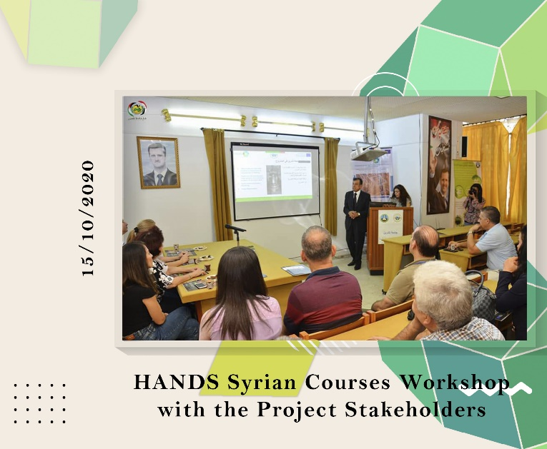
WP 5: DEVELOPMENT
Date: Thursday, 15/10/2020
Organizer: Tishreen University (TU)
Location: Tishreen University / Seminar room in the Higher Institute for Environmental Research
Syrian HANDS coordinator Prof. Al Samara led the event, welcoming participants and updating on university progress. Mr. Borrow facilitated discussions on craftsmen's role. Drs. Dalalah & Badr, Profs. Nasser & Ghadeer launched activities at Tishreen University. Partners from Jordan and other Syrian universities participated virtually, showcasing collaborative efforts and course development in design and marketing.

